**Question 2**

A website can have many subdomains and different services are running on them. Write a Python script to check the status of the subdomains which are up or down. The script should automatically check the status every min and should update it in tabular format on the screen. Write a detailed documentation of it.

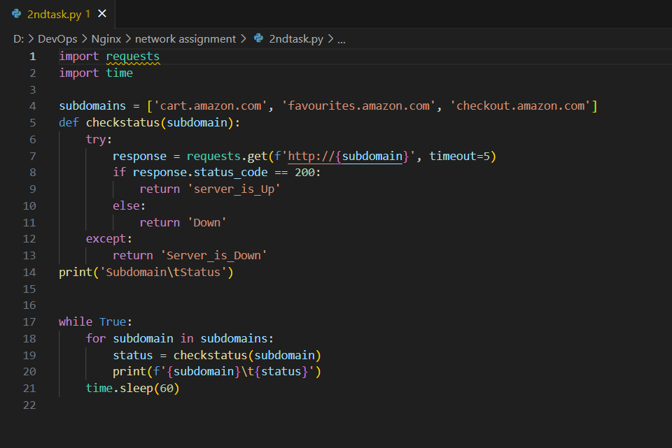

Step 1: imported requests and to check requests of the website hosted and time to operate sleep.

Step 2: defined the subdomains I wanted to check

Step 3: defined a function to check if a subfunction is up or down

Step 4: the program runs continuously recurring at 60 seconds interval.